FACULTY EVALUATION
Programme Name: Sisters’ Blended Value Program (Sbvp)Social Entrepreneurship Development Program (SEDP) Advance Module 3 Zambia (26th January 2026 - 30th January 2026)
Session: Governance and succession planning
Faculty Name: Dr. David Mutua Mathuva
No. of Respondents: 13
No. of Participants: 13
Evaluation Parameter | (%) Individual Score | (%) Programme Average
Punctuality (Commencement and Completion of Sessions) | 92 | 95
How well do you understand the core concepts presented? | 92 | 91
Rate your confidence in applying the new skills learnt | 91 | 92
Degree of Faculty preparedness for the sessions | 92 | 95
Content and methodology of the program | 94 | 96
Quality of class and group discussions | 94 | 95
The information presented in the course is relevant to my work (ministry) | 91 | 92
Average scores | 92 | 94

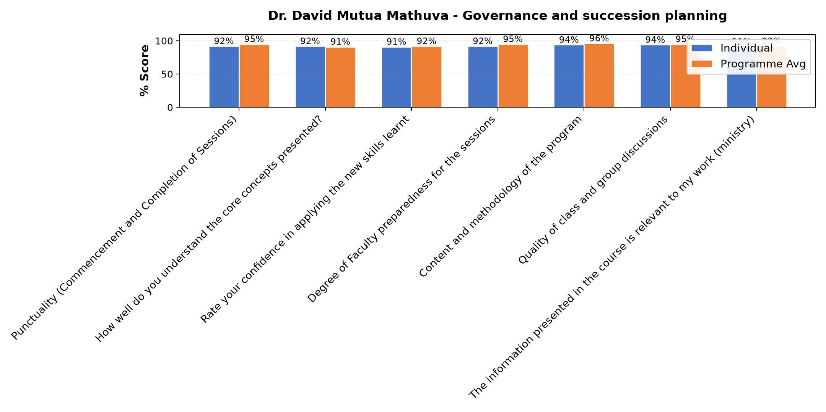

Comments & Feedback
- • No barriers will prevent me to applying it,i have learnt how to ,plan and to sale my business
- • Nothing because it's so inspiring
- • Thank a lot. The day last day was wonderful. Learning of what ZRA. I learnt how they operate in order to maintain the country 's economy and Budget how the money will be divided to different ministries and the different types of Tax that are to be paid and that you can as well be exempted from paying Tex.
- • As well an understanding mind that if not able to pay may go to the offices to let them know you are unable to pay.
- • Thanks to Dr Nancy for the highlights to finish our enterprise planning and to Dr. William to make aware of the people we can interact with who can be influencial to our enterprise in a positive way or negative way and who can take over when the person in charge has been transferred or died. Thanks as well to SR Slestine for making it a point on the leadership as well on the synod of hope.
- • Thank you so much for your insight
- • It might be time or resources but I will try to level to utilize what I have learned
- • The challenges of audibility interfered with concentration.
- • Finances
- • Lecture was very good
SUBMITTED THROUGH:
SBS Evaluation Automation System

